Information for
International Teachers 2020 – 2021

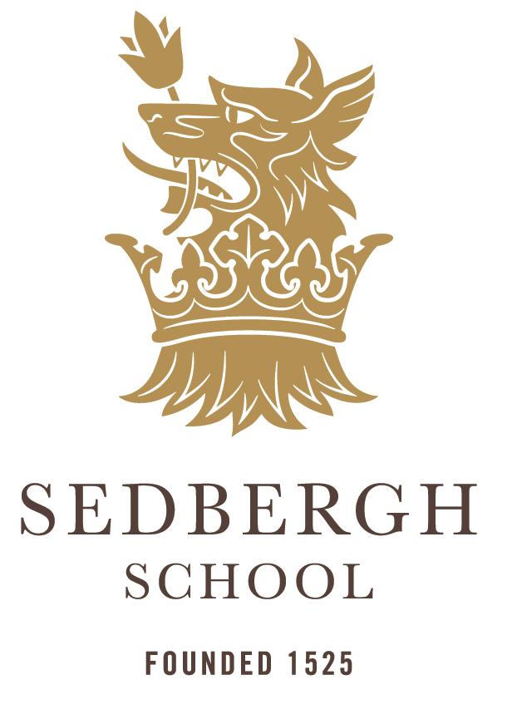

Rong Qiao Sedbergh School, Fuzhou, China
Rong Qiao Sedbergh School 融侨赛德伯学校 466 Jinbin Road, Binhai New City, Changle District, Fuzhou, Fujian, 350207, China 福建省福州市长乐区滨海新城金滨路 466 号，邮编：350207
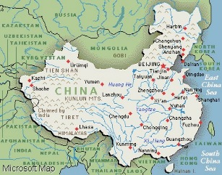
Why Fuzhou?
The school is situated 50 km from Fuzhou city, 14 km from Changle International Airport and 2 km from the coast and enjoys excellent air quality in contrast to other cities in China
Fuzhou, from the Chinese name Fu (福) implies is a city full of good fortunes (Fu). Located in the south of China, it has Taiwan across the strait to the east, Hong Kong to the south and Shanghai to the north. Though it is not as famous as some of the big cities such as HK, Beijing or Shanghai, it is an ideal destination to experience real China. Fuzhou has a subtropical climate with long hot summers and short, mild and dry winters. The average annual temperature is 19.6 ºC. In 2018 the population of Fuzhou reached 7.66 million.
Changle international airport is 15 mins from RQSS. 38 airlines fly to and from Fuzhou to 77 direct destinations including, Japan, Australia, South Korea, Thailand, Cambodia, Philippines, Taiwan, Malaysia, Singapore as well as many other airports within China.

Hong Kong is only 1 hour 45 minutes away and gateway to the rest of the world. Flight times from the UK to Hong Kong are on average of 15 hours. However some airlines take longer, based on sleepover destination and waiting duration.
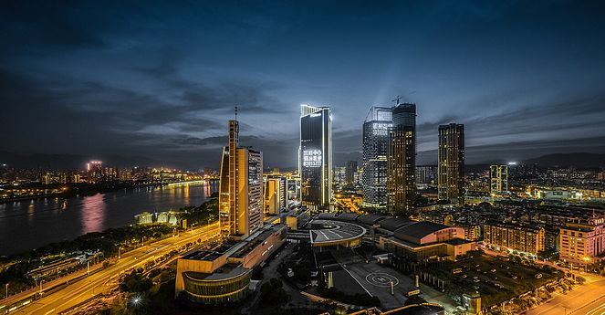
Binhai New City

Our school is situated in a new district of Changle called Binhai New City. With substantial investment from the government, RQSS is perfectly situated to embrace and benefit from the globally minded businesses in this new area spanning the coastline. With significant infrastructure projects such as road, rail, metro and sea-bridge all underway, this area of Fujian province will soon be well known for its extensive science, IT and digital sector. A new metro line (number 6) will connect Fuzhou city to Changle, RQSS and through to Changle International Airport, providing easy access to Fuzhou and the surrounding area

What is RQSS like?

Our new purpose-built campus covers a 16 hectare site and incorporates: two sports halls, an Olympic size swimming pool, lecture theatre, auditorium, recording and dance studios and many other world class facilities. Phase one is completed and phase two is due to complete by April 2020
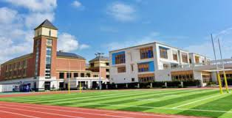
Facilities for staff on site

Staff will enjoy the benefits of many facilities available. We have sports pitches, athletics tracks, a fully equipped gym and swimming pool. We will also have a hairdressers, coffee shop, grocery shop and recreational space for staff to enjoy on their days off.
Accommodation is in within purpose built flats on-site, size dependant on family circumstances. Bus trips on Friday, Saturday and Sunday are available for staff to go into Fuzhou on days off.

Costs of living
Income tax is at a progressive rate. The first 5000RMB per month is tax exempt. The remainder of income is taxed between 3% to a maximum of 45% (as at June 2019).
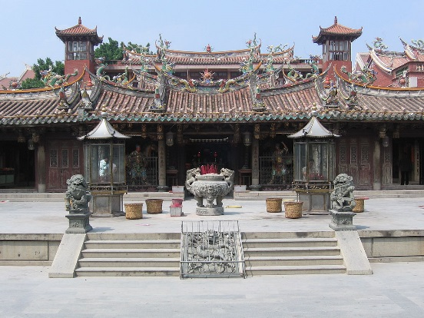
General household and amenity shopping is relatively inexpensive. Train and taxi travel is affordable. Foreign branded items, both household and food, are more expensive as they have to be imported.
Travel
There is tremendous scope for travel whilst working at Fuzhou. Many countries within Asia are within 2 – 4 hour flight times, perfect for holidays and getaways.
This is one of the most exciting parts of working in Fuzhou, experiencing the real culture of China and having the ability to travel to all parts of South East Asia whilst working at RQSS.

What can we offer you?
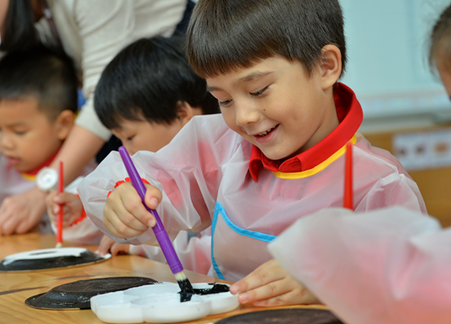
Remuneration:
- Competitive salaries based on experience and qualifications

Benefits:
- Food: 3 meals a day provided in the school dining room for you and your dependents

Facilities:
- Free use of on-site facilities

Housing:
- Furnished accommodation (1 to 4 bedrooms dependant on need) on campus is provided (utility bills included). The living quarters for teachers include modern, secure, and private apartments in a building specifically designed for foreign teaching staff.

Relocation and Ongoing Support:
- A relocation allowance of 4,000RBM for each individual teacher who needs to relocate to Fuzhou

Tuition Subsidy:
- Free tuition for up to two children (excluding uniform, text book, examination and trip costs)

Flight Allowance:
- Annual return air ticket for each academic year to a total of £12,000RMB per person and dependents
- Insurance: Comprehensive Worldwide medical insurance coverage (excluding USA).
- Health check costs (in China)

Equipment:
- Staff laptop

Visa:
- Application costs of 4,000RBM *
- and reduction of fees at local golf club

Professional Development:
- Opportunities to develop further qualifications to enhance teaching and your career.

